Highly Available Web Application with Auto Scaling on AWS

Project Overview:
A startup requires a highly available and scalable web application infrastructure to handle unpredictable traffic spikes without downtime.
The architecture uses EC2, Auto Scaling Group, Application Load Balancer, EBS, and VPC networking across multiple Availability Zones.

Architecture:
Internet → Application Load Balancer → Auto Scaling Group (EC2 instances across two Availability Zones).
Each EC2 instance runs Apache and stores application files on EBS.

Step 1: Create Custom AMI
Launch an EC2 instance, install Apache, deploy the application, then create an AMI from the configured instance.
Commands:
sudo apt update
sudo apt install apache2 -y
sudo systemctl start apache2
sudo systemctl enable apache2

Step 2: Security Groups
ALB Security Group:
Allow HTTP (80) and HTTPS (443) from the internet.
EC2 Security Group:
Allow HTTP (80) only from public
Allow SSH (22) only from public

Step 3: Launch Template
Launch Template Name: demo-template
Configuration includes:
Custom AMI, instance type, key pair, EC2 security group, and EBS storage.
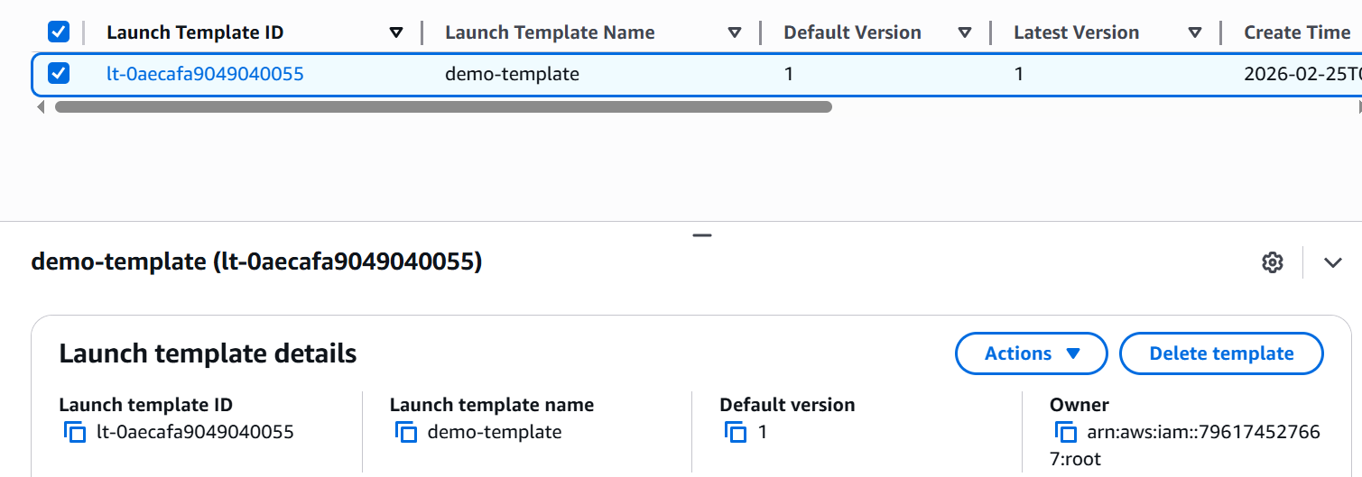

Step 4: Target Group
Name: New-target
Protocol: HTTP
Port: 80
Health check path: /
Healthy threshold: 3
Unhealthy threshold: 2
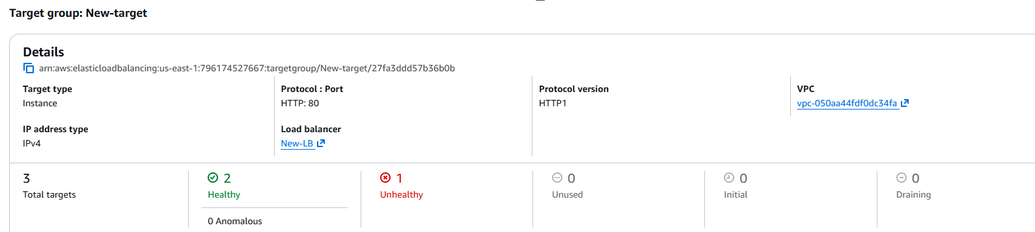

Step 5: Application Load Balancer:
Internet-facing ALB listening on port 80.
Attached to target group (New-target).
Configured across two Availability Zones.
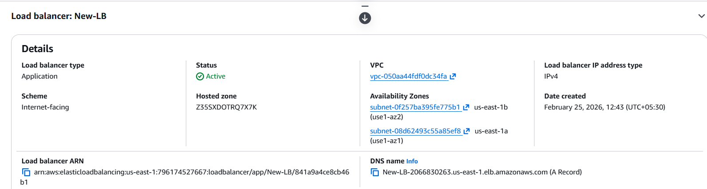

Step 6: Auto Scaling Group:
ASG Name: New-ASG
Launch Template: demo-template
Min capacity: 2
Desired capacity: 2
Max capacity: 4
Subnets across two Availability Zones.
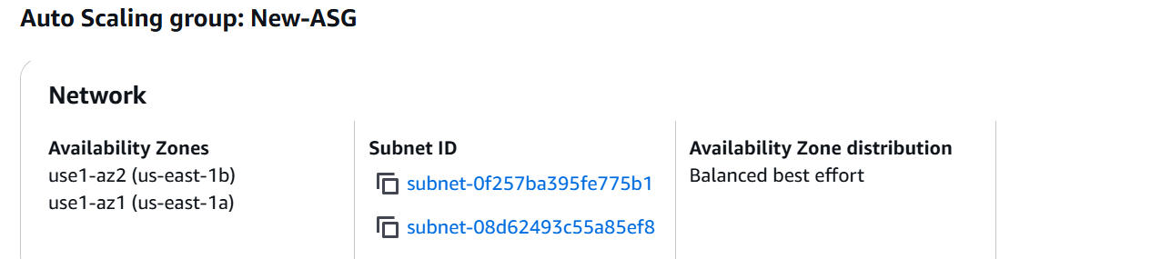

Step 7: Auto Scaling Policies
Scale-out when CPU ≥ 70%.
Scale-in when CPU ≤ 30%.
Metric used: Average CPU Utilization.
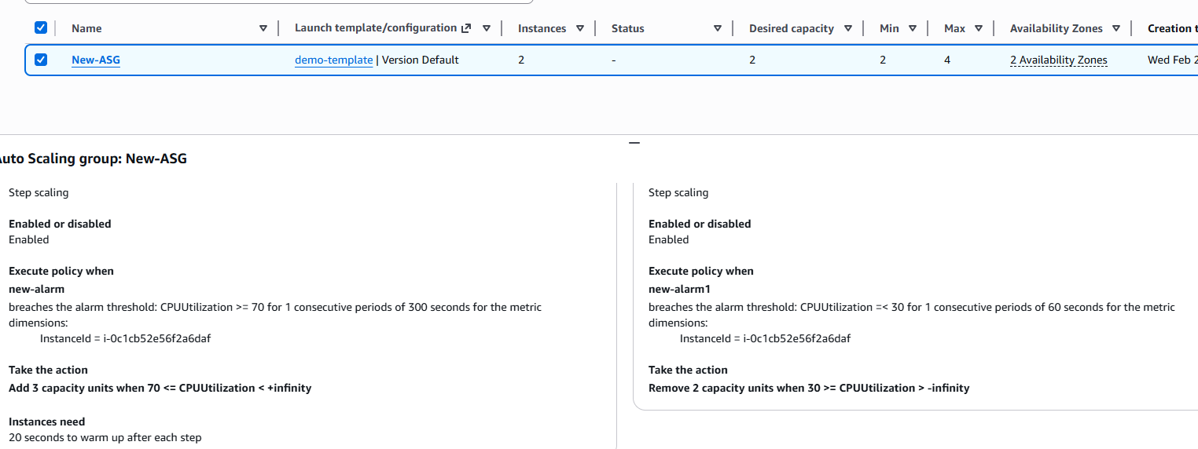

Why ALB not NLB?
Application Load Balancer works at Layer 7 and supports HTTP/HTTPS routing, which makes it ideal for web applications, unlike Network Load Balancer which operates at Layer 4.

Why use Launch Template instead of Launch Configuration?
Launch Templates are preferred because they support versioning, advanced configurations, and are the modern replacement for Launch Configurations.

